**Bahria University, Islamabad Campus**

Department of Computer Science

Mid Term Examination

Class/Section: BSCS 6A,6C,6D

**(Spring 2024 Semester)**

|  |  |
| --- | --- |
| **Paper Type: Solution of Descriptive Part** |  |
| Course: Artificial Intelligence | Date: 15-03-2024 |
| Course Code: CSC-325 | Session – IV |
| Faculty's Name: Mr. Usama Imtiaz, Mr. Abdul  Salam, Mr. Israr Akhtar | Max Marks: 20 |
| Time Allowed: 90 minutes | Total Pages: 7 (including this) |

* This is a closed-book exam. Communication devices and any written material is strictly prohibited.
* All questions are compulsory.
* Comprehension of questions is part of the exam. Use blue/black pen only. - **The answer sheet is not required**.

|  |  |  |  |  |
| --- | --- | --- | --- | --- |
|  | **CLO 2 BT=C2** | **CLO 1 BT=C1** | **CLO 3 BT=C4** | **Total** |
| Question No # | **Q.1** | **Q.2** | **Q.3** |
| Total Marks | 6 Marks | 3 Marks | 11 Marks | **20 Marks** |
| Obtained Marks |  |  |  |  |

Student’s Name: Enrollment No:

Invigilator's Name: Signature:

**Question # 1** (3+3 Marks)

1. You're browsing an online warehouse website, and it suggests products similar to the ones you've recently viewed. How does the AI-powered recommender system work behind the scenes to provide personalized product recommendations? Which type of agent is helping you in searching and recommending similar products? **(CLO-2,BT=C2)**

1. Consider the teacher agent delivering the lecture in the class. Define its environment in terms of observability, determinism, episodic, static, and discreteness. **(CLO-2,BT=C2)**

# Question # 2 (3 Marks)

Explain the concept of AI smart agents and their role in artificial intelligence. Discuss the characteristics and functionalities of smart agents, including perception, reasoning, learning, and action. Provide examples of real-world applications where smart agents are used to perform tasks autonomously or assist users in decision -making. Discuss the challenges and ethical considerations associated with the deployment of smart agents in various domains. **(CLO-1,BT=C1)**

**Question # 3** (5 Marks)

a. Apply Uniform Cost Search on the following directed graph. Your starting node is A and goal node is J. For tie breakers use alphabetical order. **(CLO-3,BT=C4)**

1. Draw the parse tree
2. Highlight the final path from start to end.
3. Fill the visited sequence in the table below

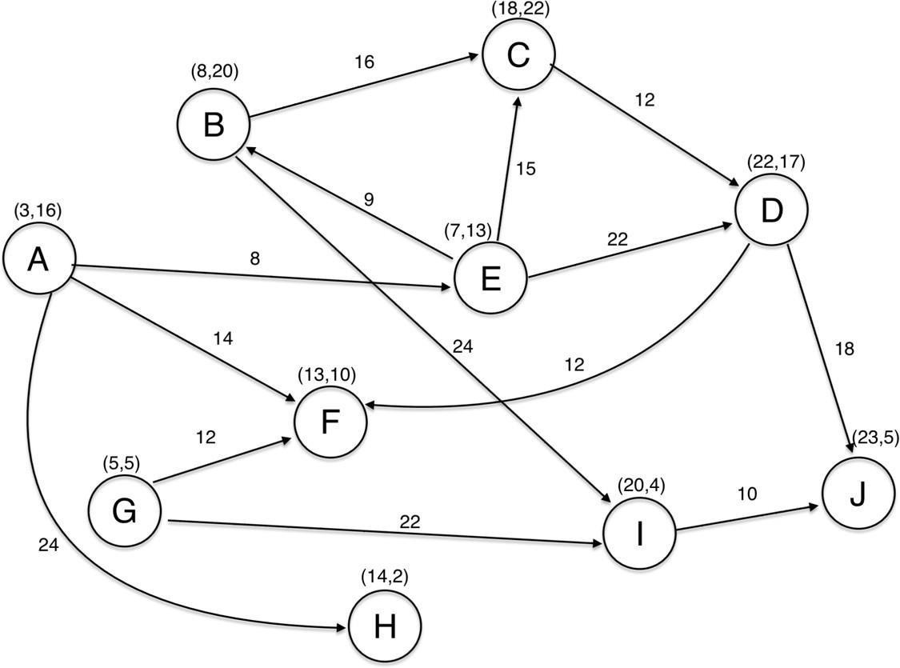

|  |  |  |  |  |  |  |  |  |  |
| --- | --- | --- | --- | --- | --- | --- | --- | --- | --- |
| **Visited**  **Node** |  |  |  |  |  |  |  |  |  |
| **Cost** |  |  |  |  |  |  |  |  |  |

## Question # 3 (6 Marks)

b. Apply A* Search on the following directed graph. Your starting node is A and goal node is J. For heuristic cost h(x) use Euclidian distance. For tie breakers use alphabetical order.

1. Euclidian distance Formula:

𝑑𝑖𝑠𝑡[(x1, y1), (x2, y2)] = sqrt [(x1 − x2)2 + (y1 − y2)2] x and y values are mentioned on the node.

1. Calculate the h(x) for each node and mention it on the table on the side
2. Fill the visited sequence in the table below
3. Draw the parse tree
4. Highlight the final path from start to end

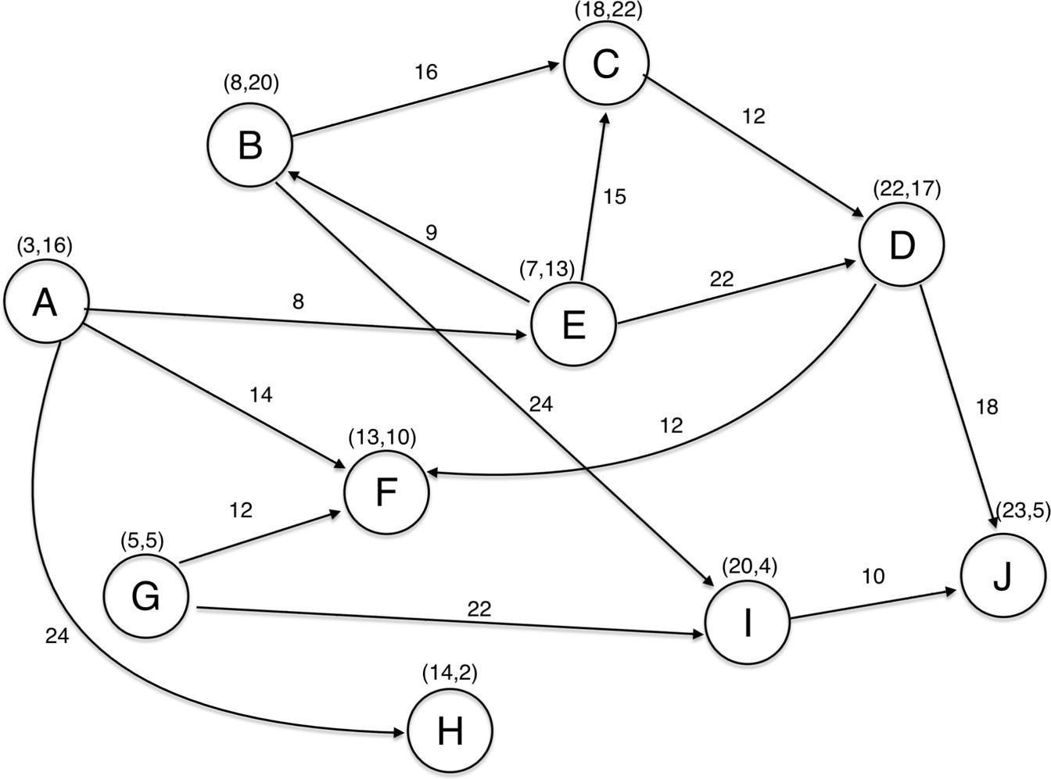

## 

|  |  |  |  |  |  |  |  |  |  |
| --- | --- | --- | --- | --- | --- | --- | --- | --- | --- |
| **Visited**  **Node** |  |  |  |  |  |  |  |  |  |
| **Cost** |  |  |  |  |  |  |  |  |  |